MILFORD ON SEA PARISH COUNCIL
COMMITTEE MEETING DATES 2025
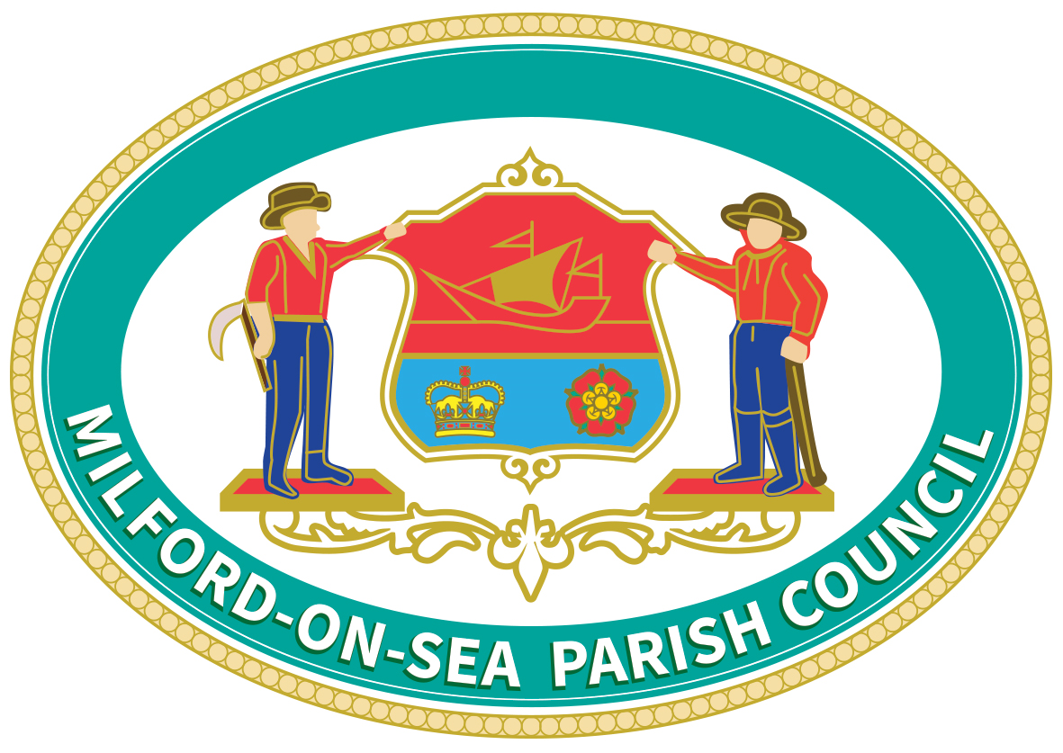
MONTH | PLANNING | PARISH  COUNCIL | ANNUAL PUBLIC  MEETING | Finance & Forward Planning | Amenities, Woodland, Coastal & Environment | Tourism, Traders & Traffic | Other -  Training
 | 6.30pm | 6.30pm | 7.30pm | 10.30am | 10.30am | 10.30am | 5.00pm
JAN | 13
 |  | 20
FEB | 3 |  |  | 24
 |  |  |  |  |  |  | 17
MAR | 3 |  |  |  | 11
 |  | 17
APR | 7
 |  | 28
MAY | 6 (Tuesday)
 |  | 19 (AGM)
 |  |  | 28*(Weds)
JUNE | 2 |  |  | 9
 |  | 16
JULY | 7
 |  | 21
AUG | 4
 |  |  |  |  |  |  | 18
SEPT | 1 |  |  |  |  | 23
 |  | 15
OCT | 6 |  |  |  | 14
 |  | 20
NOV | 3 |  |  | 24
 |  | 17
DEC | 1
 |  | 8

MEETINGS ARE ON A MONDAY EVENING IN THE VILLAGE HALL, PARK ROAD, UNLESS OTHERWISE STATED.
THE ANNUAL PUBLIC METING ON WEDNESDAY MAY 28th WILL BE HELD AT ALL SAINTS CHURCH HALL
* A meeting for the residents rather than a formal Parish Council Meeting.
The Finance, Amenities, Tourism & Other Committees are not public meetings. However, the Parish Council are likely to invite interested parties to certain meetings and minutes of these meetings will be publicly available.
All meetings other than Planning and Full Parish Council will be held in the Parish Office

